Douglas Bowers

CS-330

10/17/2024

7-1 Final Project

For my 3D scene, I chose to recreate a guitar amplifier, a Pokeball, a Kirby figure, and a pumpkin creature figure.

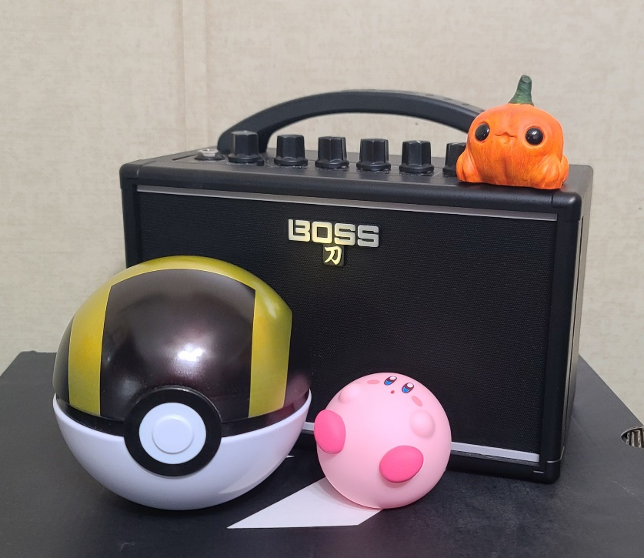

I chose to recreate these objects because of the many different shapes that would be required to create them. I used a multitude of different sized boxes, spheres, cones, and tori to accomplish in the creation of each of these, with the amplifier being the most complex of these objects. For the Pokeball, I had to use two half spheres, rotating one of them 180 degrees while leaving a gap between them to create the lip that is on the top and bottom. I then used sphere on the inside to fill the space. For the white and black circle on the front, I had to flatten out some spheres and sink them into the front of it. While the amplifier was the most complex, the one that took the most time was the Kirby figure, as I had to stretch, flatten, and position the arms and legs into their respective places. As for the pumpkin creature figure, this was mostly comprised of different shaped spheres and a cone. The amplifier, however, was the most complex, requiring the greatest number of shapes, depth, and positioning. From the lip around the speaker mesh, to the specifically placed knobs on the top, this object contained 14 total shapes to create.

When it comes to the navigational component of the 3D scene, the standard directions of the camera can be controlled using WASD, W moves forward, A moves left, S moves right, and D moves backward. I also added the ability to slow or speed up the camera movements using the scroll wheel. Additionally, you can press Q to move up vertically, and E to move down vertically. For static views, you can press O for an orthographical view, or P for a perspective view. For lighting, I used point lighting set to different positions around the scene to allow for shadows and shine on the objects to create a more realistic look. While my initial scene was very bright, I wanted to create more depth with my recreation, so I used different intensities, colors, and locations of ambient, diffuse, and specular lighting to help with that.

When creating the code for my scene, I tried to keep everything as organized as possible. I sectioned each block off from the other, allowing for improved searchability and readability. I kept my textures, lighting, materials, and objects within their own space to promote reusability and customization. This will be helpful when modifying the values of shapes, lights, or even changing entire objects as they are all labeled and organized.